*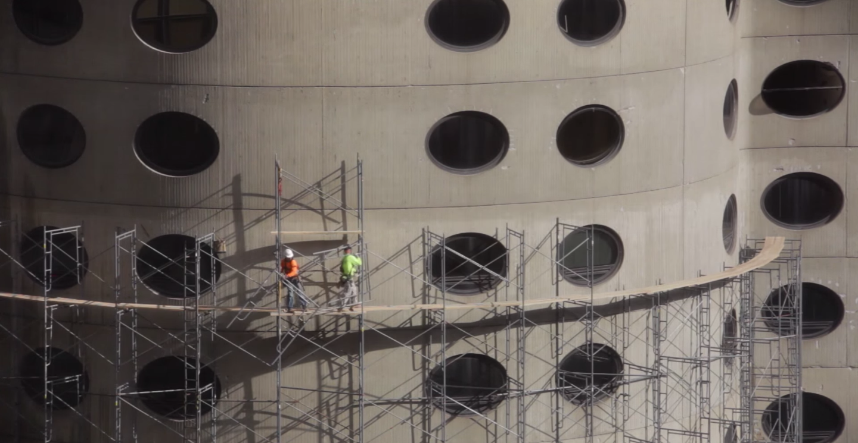*

*fig 1.* I ate alone at Potbellys and I was not nourished. I watched a movie in which the institution demolishes the hospital where I was born, unfolding as it goes into the raw open, an unfathomed wound, and I was not nourished. I watched it again, and I was not nourished. At the time, I drew a small monthly stipend from the institution, and yet I was not nourished. I fell on the ice and my shoulder caught me. Still I was not nourished. The fall lingered in my shoulder, a stuckness which would not nourish. In fact, the wound advanced through the house until it became hard abundance of leaf. Still I was not nourished.

On the phone, my father asked: “How does your labor read as sorrow?” My labor does not nourish, I said. The poem acts as the institution’s hammer. It tears without repair. It ends by making the body fruitful. “What does a body nourish?” he asked. “Obviously time heals no wounds. Obviously it multiplies the mouth. It can be cured only by the end of life.” Why do I seek the living? Because they do not nourish. All winter, I stopped my eyes and ears with dense paper, to shut out the sweet recent. All winter, I promised myself: this mouth is dread. Nothing no longer can be said. Still I was not nourished.

*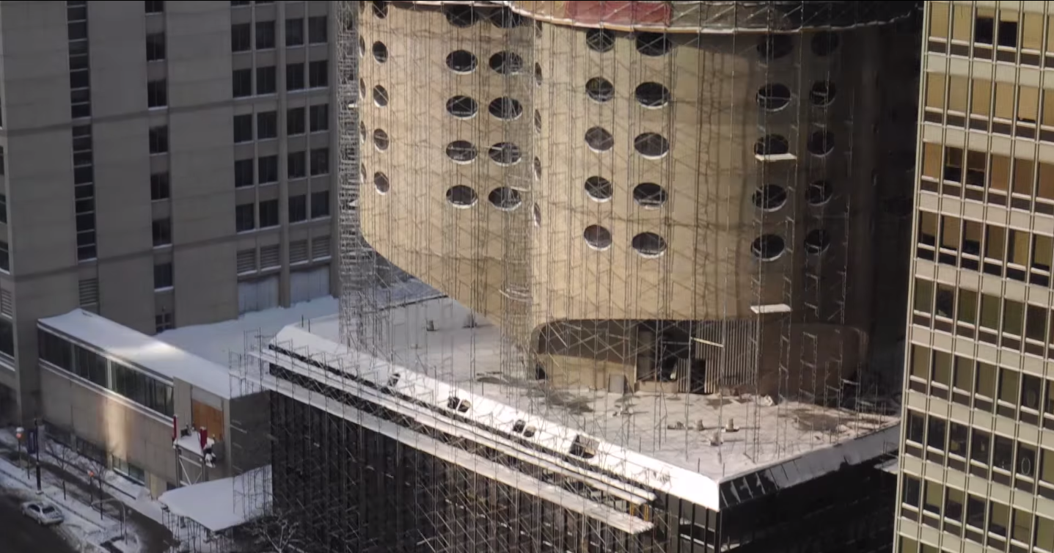*

*fig 2.* I imagine a building that inflicts escalating, persistent pain. This architecture does not permit mutation or break in the substance of the building. This architecture does not open. Its pain is legible. As a collar. It promises gradual release. From history, error, and loss. Into a brightly lit institutional space. In the absence of such objects, the armored personnel carrier appears as an elegant vessel for the divine, the dense spirit who traffics in wool, beet-root sugar, and potato spirits. Who speaks, when he speaks at all, in emulsified concrete.

This kind of falling is contagious. The bruise of the fall put my shoulder out of joint. Now the grinding passes into the earth. For a week, or maybe more, spars of brute concrete pierced the damp mirror. Afterward, I began to conceive of the ground as a weapon. I wrote in my notebook, “The human is / the transfer of / concrete / in itself.” Then: “The stone is / absorbed / in / the staircase.” I thought the future would bring a place of succulence and denial. A perishing retail center. Instead, I stand in the bottomless event and translate the sculpture back into stone. There is nothing to see here.

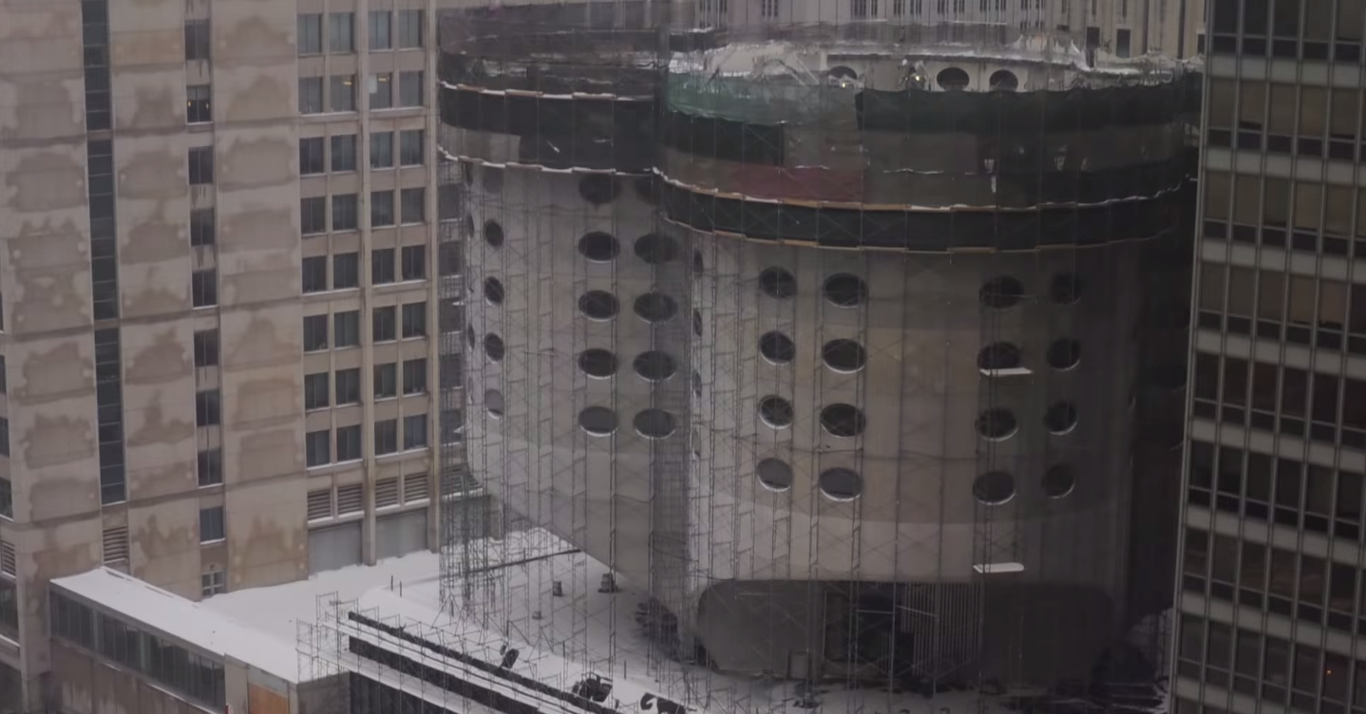

*fig 3.* In the post war period,the management of meaning became the management of bodies: how to smooth their temporal pleats. The spars of brute concrete. The communal task of total war. This sentimental landscape has therefore been carefully organized as a packaged thinness. An intrinsic tendency toward orderly repetition. To reduce everything to simple, abstract, material volumes. To expose, accentuate, and toughen, the elements of simple building. Thus architecture becomes a journey without arrival. It ends by making the camera feeling.

Now my joint is hunted throughout. It becomes a hill of frost. I refuse to unfold its interior sweetness. The soft centrality which language nourishes. I refuse to unfold. Instead, I write the word ‘wound.’ Then I write it again. Is this a way of making it behave. Do I want to multiply its penetration. Why not. Every entrance is a weapon. Every entrance is a wound. I write the wound I lack. I lack the dark audacity to let myself be fucked. To open as a city opens. To anyone who wants to come. This kind of geography is contagious.

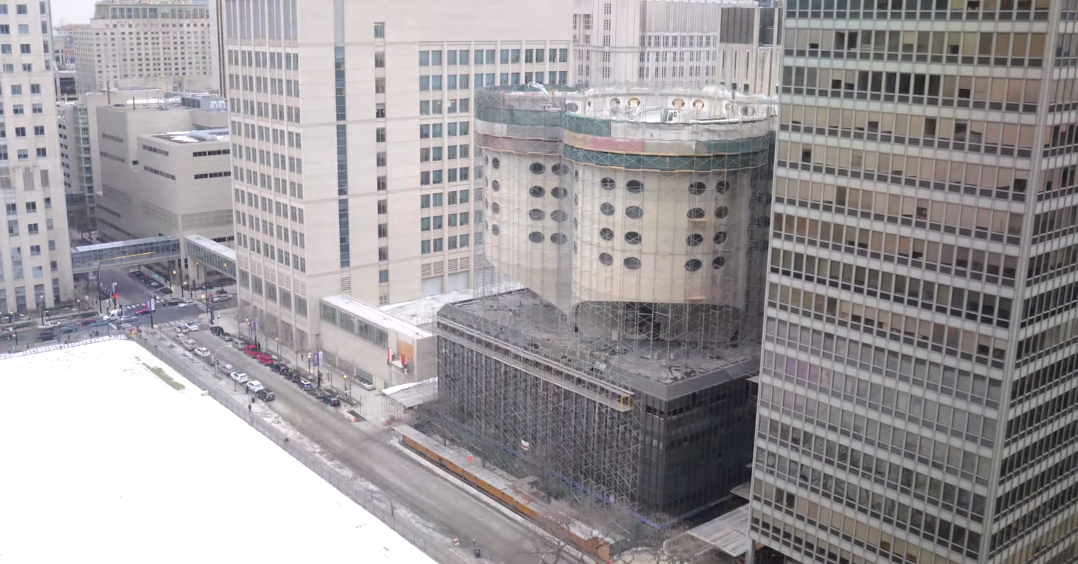

*fig 4.* At the institution a woman says, “I don’t know where my body is going.” I too descend into muteness. Even my language asks me to be in a state of exile. “The step of the wandering Jew is in every son,” says Djuna Barnes. I too disappear into the lens. While my students look away, I massage the stony edge of my shoulder. This kind of touching makes the knot sharper. “This kind of stone cannot learn,” the institution says, “to be tender.” With my stipend, I buy hot pads and ice packs. I strip my shirt and lay them on my shoulder. Now the knot is loose in the world as such.

Don’t tell me that isn’t lovely. Don’t tell me that isn’t loss. Even my language asks me to be loss. One self is a winter. All my other self is gone. “Wherever you meet him,” (Barnes again) “you feel that he has come from…some country that he has devoured rather than resided in.” Eileen says that language has two functions: inventory and prophecy. Like money, all it says is loss. In this film, the institution’s money is visible as a series of cuttings. It slowly severs the tendon from the ankle. Without reprieve or repair. “That’s nice,” says the institution. “Now replace ‘it’ with ‘I.’”

*bio:* Toby Altman is the author of four chapbooks, including recently *Tender Industrial Fabric* (Greying Ghost, 2015) and *Same Difference* (Shirt Pocket, 2015). His poems can or will be found in *Best American Experimental Writing, 2014*, *The Black Warrior Review*, *Crazyhorse*, *Diagram*, and other journals and anthologies.